MARCH 2024
Sun. | Mon. | Tue. | Wed. | Thu. | Fri. | Sat.
 |  |  |  |  | 1 | 2
 |  |  |  |  | Game Club 9:00  Basketball Practice 10:00  Pine Castle Connects Live Show from the Yard | Pine Castle PJ Day at Bruster’s - $1 Ice Cream Cone  (see additional flyer)
3 | 4 | 5 | 6 | 7 | 8 | 9
 | Basketball Practice 10:00  Band Practice 12:00  Library  Community Outing | Bible Study 10:00  Chair Exercises 12:00  Band Practice 12:00  Courtyard Games 1:00  Dollar Tree  Community Outing | Walking Club 10:00  Music Club 12:00  National Oreo Cookie Day | Bible Study 10:00  Chorus 10:00  Senior’s Social Line Dancing | Game Club 9:00  Basketball Practice 10:00  Bingo 12:00  Basketball Game 1:15 | FLASHBACKS BAND Performance at Riverside Arts Market
10 | 11 | 12 | 13 | 14 | 15 | 16
DAYLIGHT SAVINGS DAY | 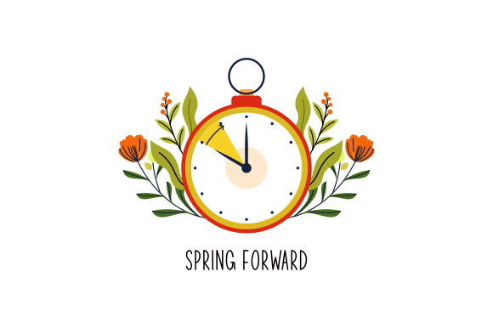  Basketball Practice 10:00  Band Practice 12:00 | Bible Study 10:00  Chair Exercises 12:00  Band Practice 12:00  Courtyard Games 1:00  Target  Community Outing | Walking Club 10:00  Music Club 12:00 | CPR/FA Training  Bible Study 10:00  Chorus 10:00  Senior’s Social  Cooking Demo | PINE CASTLE CLOSED  (INSERVICE)
17 | 18 | 19 | 20 | 21 | 22 | 23
ST. PATRICK DAY  /31 | Basketball Practice 10:00  Band Practice 12:00  Library  Community Outing | Bible Study 10:00  Chair Exercises 12:00  Band Practice 12:00  Courtyard Games 1:00  Zoo  Community Outing | Walking Club 10:00  Music Club 12:00  Dollar Tree Community Outing | New Staff Orientation  Bible Study 10:00  Chorus 10:00  Senior’s Social  Arts & Craft | Game Club 9:00  Basketball Practice 10:00  Spring Band Concert 12:15  Basketball Game 1:15 | Jacksonville ICE MEN Hockey is for Everyone JAX  (see additional flyer)
24 | 25 | 26 | 27  Walking Club 10:00  March Birthday Music Club 12:00 | 28  Spring Chorus Concert 10:15  Civitan in Shop 3 11:45  Senior’s Social Chair Yoga Activity | 29  Game Club 9:00  Basketball Practice 10:00  Bingo 12:00  Basketball Game 1:15 | 30
 | Basketball Practice 10:00  Band Practice 12:00  Career Fair Community Outing | Bible Study 10:00  Chair Exercises 12:00  Band Practice 12:00  Courtyard Games 1:00  Walmart  Community Outing

Curriculum Information: Lesson 3 starts February 26th through March 20th

In order to ensure our participants' success in the academy, we do request that you adhere to the day program's operating hours of 8:30 a.m. - 2:30 p.m.

As a reminder, drop-off is between 8-8:30 a.m. and pick-up is between 2:30-3 p.m.

Flag Raising and Pledge of Allegiance – Daily at 8:45 a.m.

